Requirement Analysis
Data Flow Diagram
Date | 02 October 2026
Student Name | Dhanyaa V S
Project Name | Automated Network Request Management in ServiceNow

DATA FLOW ARCHITECTURE (DFD LEVEL 0, 1 & 2)
Data Flow Diagrams (DFDs) map the movement of data through the ServiceNow system. They define external system boundaries (Level 0), show how data flows into database tables (Level 1), and explain the detailed step-by-step logic used during form validation, approval routing, and task fulfillment (Level 2).
1. Context Diagram (Level 0 DFD)
The Level 0 Context Diagram represents the entire automated network platform as a single process (0.0). It maps inputs and outputs between the four main external entities: End Users, Approvers, Network Operations, and Auditors.
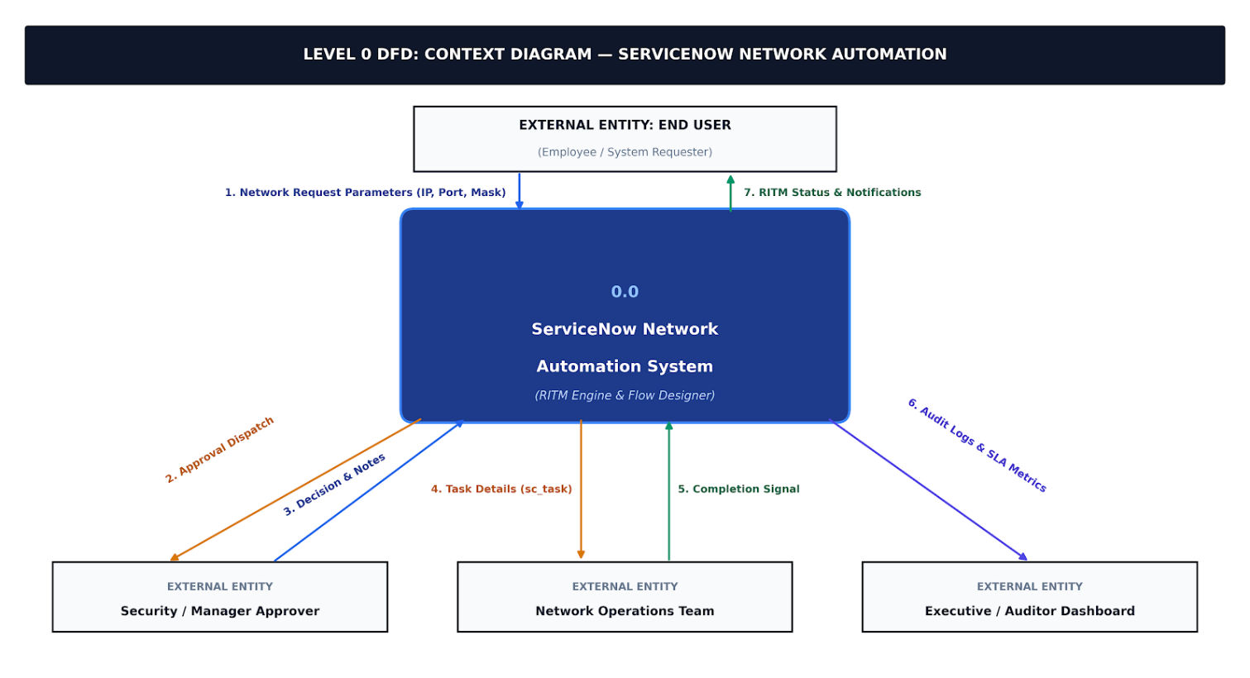
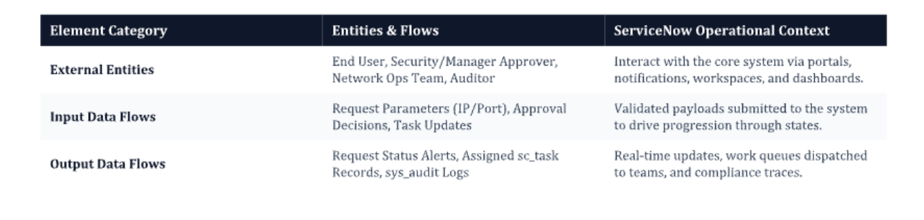
2. Detailed Data Flow Diagram (Level 1 DFD)
Level 1 decomposes the main system into six sequential subprocesses (1.0 through 6.0) and shows their direct read/write connections to six core ServiceNow database tables (D1 through D6). This structure ensures that every network change is logged and traceable from submission to fulfillment.
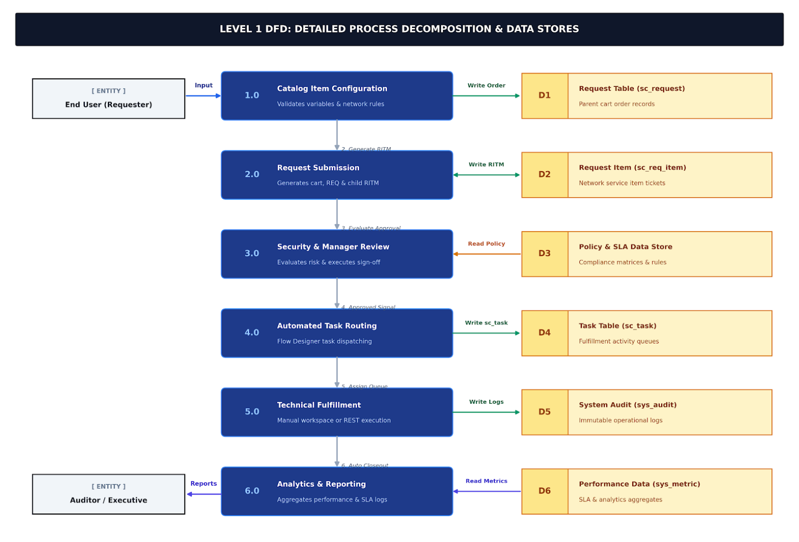

3. Level 2 DFD — Subprocess Specifications
In DFD design, only processes with complex internal decision paths require detailed Level 2 breakdown. Processes1.0 (Intake), 3.0 (Security Approval), and 5.0 (Technical Fulfillment) involve branching logic and multiple sub-steps, whereas processes 2.0, 4.0, and 6.0 represent direct atomic database operations.
Process 1.0: Request Submission & Validation
- 1.1 Load Form & Variables: Retrieves network variable fields (Source/Destination IP, Subnet Mask, Port, Protocol) into the form.
- 1.2 Client-Side Validation: Client Scripts and UI Policies check CIDR notation, IP formats, and ensure required fields are filled.
- 1.3 Create Order Records: Validated inputs are saved to sc_request and sc_req_item, generating the unique RITM number.
Process 3.0: Approval & Policy Enforcement
- 3.1 Evaluate Risk Rules: Flow Designer evaluates destination network zones and sensitive ports (e.g., SSH, RDP) against security policies.
- 3.2 Dispatch Approvals: Approval tasks (sysapproval_approver) are sent via email and portal notifications to the manager and security officer.
- 3.3 Log Decision: Approver comments and decisions are logged in sys_audit, moving the RITM state to Approved or Rejected.
Process 5.0: Task Execution & Integration
- 5.1 Task Generation: Upon approval, Flow Designer automatically creates a fulfillment task (sc_task).
- 5.2 Queue Assignment: Assignment rules place the task into the Network Security Ops or IPAM team queue.
- 5.3 Fulfillment Execution: Engineers fulfill the request in Network Workspace, or IntegrationHub triggers REST API / Ansible playbooks to update network devices automatically.
- 5.4 Task Closeout: Marking sc_task as Closed Complete updates the parent RITM status to Fulfilled.

